**Coffee Shop Sales**

**Data Cleaning:-**

describe coffee_shop_sales;

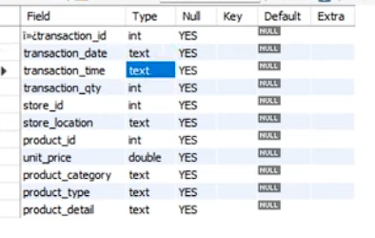

**Q1 Change transaction_date & transaction_time into date and time datatype also rename the ï»¿transaction_id into transaction_id ?**

update coffee_shop_sales

set transaction_date = str_to_date(transaction_date, '%d-%m-%Y');

Alter table coffee_shop_sales

modify column transaction_date date;

update coffee_shop_sales

set transaction_time = str_to_date(transaction_time, '%H:%i:%s');

Alter table coffee_shop_sales

modify column transaction_time time;

Alter table coffee_shop_sales

change ï»¿transaction_id transaction_id int;

describe coffee_shop_sales;

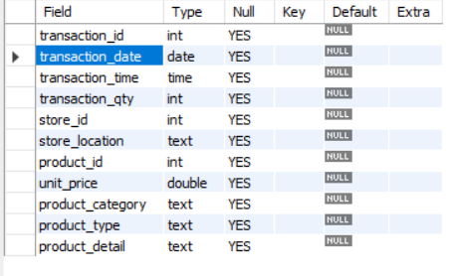

**KPI:-**

**Total Sales**

select round(sum(unit_price*transaction_qty),0) as Total_sale

from coffee_shop_sales

where month(transaction_date) = 5; -- 5 = may month

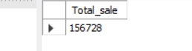

**-- % MOM increase and decrease in sales**

**MOM increase and decrease in sales =** (Current Month sales – Previous month sales / Previous Month sales) * 100

select

month(transaction_date) as Month_Number,

round(sum(unit_price * transaction_qty)) as Total_sales,

(sum(unit_price * transaction_qty) - lag(sum(unit_price * transaction_qty),1) over (order by month(transaction_date)))

/ lag(sum(unit_price * transaction_qty),1) over (order by month(transaction_date)) *100 MOM_Sale_Percantage

from coffee_shop_sales

group by month(transaction_date)

order by month(transaction_date);

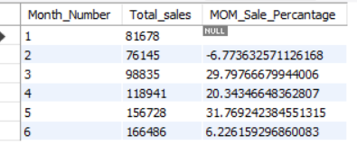

**Q4 total no. of order**

select month(transaction_date) as month,count(transaction_id) as Total_order

from coffee_shop_sales

group by month(transaction_date);

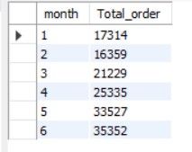

**Q5 display mom increase in order count?**

select

month(transaction_date) as month,

count(transaction_id) as Total_order,

(count(transaction_id) - lag(count(transaction_id),1) over (order by month(transaction_date))) /

lag(count(transaction_id),1) over (order by month(transaction_date)) *100 as mom_increase_order

from coffee_shop_sales

group by month(transaction_date)

order by month(transaction_date);

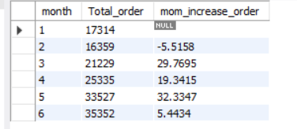

**Q6 total Quantity sold?**

select month(transaction_date) as month,sum(transaction_qty) as Total_Quantity_sold

from coffee_shop_sales

group by month(transaction_date);

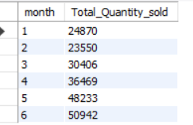

**Q7 MOM increase in order quantity?**

select

month(transaction_date) as month,

sum(transaction_qty) as Total_Quantity_Sold,

(sum (transaction_qty) - lag(sum(transaction_qty),1) over (order by month(transaction_date))) /

lag(sum (transaction_qty),1) over (order by month(transaction_date)) *100 as MOM_Quantity_Sold

from coffee_shop_sales

group by month(transaction_date)

order by month(transaction_date);

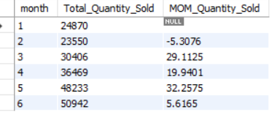

**Q8 find out total sale,total Quantity, total orders for 24-05-2023 date also use "K" thousand behind the result?**

select concat(round(sum(transaction_qty * unit_price)/1000,1), 'K') as Total_sale,

concat(round(sum(transaction_qty)/1000,1), 'K') as Total_Quantity_Sold,

concat(round(Count(distinct transaction_id)/1000,1), 'K') as Total_order

from coffee_shop_sales

where transaction_date = '2023-05-18';



Weekends = Saturday and Sunday also Remember that Sunday = 1 & Saturday =7 on week Number

Weekday = Monday to Friday

**Q9 categerioes the weekday and weekend sales data?**

select

concat(round(sum(transaction_qty * unit_price)/1000,1),'K') as Total_sales,

Case when dayofweek(transaction_date) in (1,7) then 'Weekend'

else 'Weekday'

end Day_type

from coffee_shop_sales

group by Case when dayofweek(transaction_date) in (1,7) then 'Weekend'

else 'Weekday'

end;

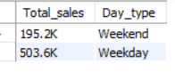

-- in case we need only may month weekday & weekend sale so after from we use where condition(where month(transaction_date) = 5 here 5 repersent may month number.

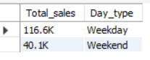

**Q10 sales data for different store location?**

select

store_location,

concat(round(sum(transaction_qty * unit_price)/1000,1),’K’) as Total_sales

from coffee_shop_sales

group by store_location

order by sum(transaction_qty * unit_price) desc;

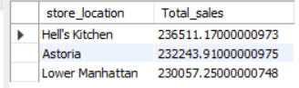

-- find out where transaction_date = '2023-05-18' and store_location = 'Hell''s Kitchen' this condition total_sales



**Q11 Average sales based on month?**

select

avg(transaction_qty * unit_price) as Avg_sale

from coffee_shop_sales

where month(transaction_date) = 4;



-- Here for april month output is wrong because Avgerage formula is = sum of total order / count of order

-- but (transaction_qty * unit_price) we do multiplication so no sum for accurate answer firstly we do sum of transaction_qty * unit_price

-- then average.

-- for this we use subquery

select

concat(round(avg(total_sale)/1000,1),'k') as Avg_Total_sale

from

(select sum(transaction_qty * unit_price) as total_sale

from coffee_shop_sales

where month(transaction_date) = 4

group by transaction_date) as internal_query



**Here I notice that if I not alise the subquery name so query not execute**

**Q12- Show dailey sale for may month?**

select

day(transaction_date) as Day_sale,

concat(round(sum(transaction_qty * unit_price)/1000,1),'K') as Total_sale

from coffee_shop_sales

where month(transaction_date) = 5

group by day(transaction_date);

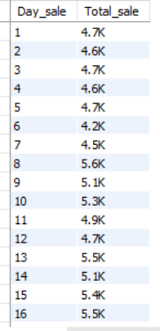 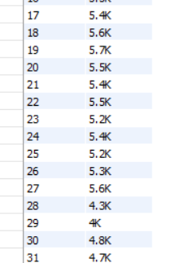

**Q13- Based on dailey sale and avg sale for may month also if sale id greater then avg sale then above sale and wise versa?**

SELECT day_of_month,avg_sales,total_sales,

CASE

WHEN total_sales > avg_sales THEN 'Above Average'

WHEN total_sales < avg_sales THEN 'Below Average'

ELSE 'Average'

END AS sales_status

FROM (

SELECT

DAY(transaction_date) AS day_of_month,

SUM(unit_price * transaction_qty) AS total_sales,

AVG(SUM(unit_price * transaction_qty)) OVER () AS avg_sales

FROM coffee_shop_sales

WHERE MONTH(transaction_date) = 5 -- Filter for May

GROUP BY DAY(transaction_date)

ORDER BY day_of_month;

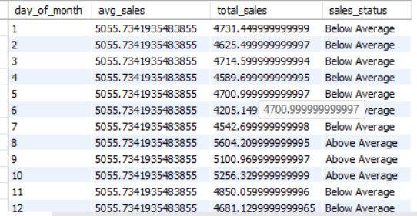

Here I got a error msg in avg_sales if I not use OVER () function error msg is Error Code: 1111. Invalid use of group function

This error because of

**Q14 find out total sale under product_category?**

select product_category,sum(unit_price * transaction_qty) as Total_sale

from coffee_shop_sales

group by product_category;

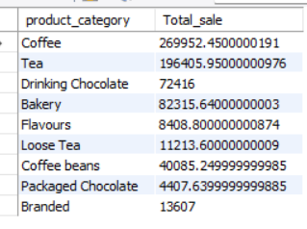

We also find out the value for specified month eg for may month category by sale

select product_category,sum(unit_price * transaction_qty) as Total_sale

from coffee_shop_sales

where month(transaction_date) = 5

group by product_category

order by sum(unit_price * transaction_qty);

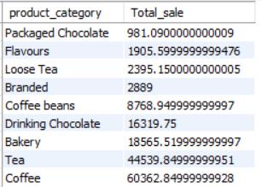

**Q14 find out top 10 total sale under product_type?**

select product_type,sum(unit_price * transaction_qty) as Total_sale

from coffee_shop_sales

group by product_type

order by sum(unit_price * transaction_qty) desc

limit 10;

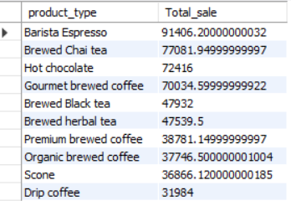

**Q14 Find out the total sale done in each hour for 6 may month?**

select hour(transaction_time) As Transaction_Hour,sum(transaction_qty * unit_price) as Total_sale

from coffee_shop_sales

where month(transaction_date) = 5

and dayofweek(transaction_date) = 6

group by hour(transaction_time)

order by hour(transaction_time);

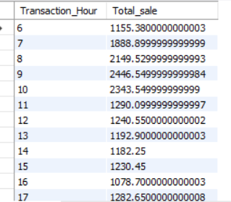

**Q15 find out total sale,total quanitity,total order for 3 may and till 8 hours?**

select

concat(round(sum(transaction_qty * unit_price)/1000,1), 'K') as Total_sale,

concat(round(sum(transaction_qty)/1000,1), 'K') as Total_Quantity_Sold,

concat(round(Count(distinct transaction_id)/1000,1), 'K') as Total_order

from coffee_shop_sales

where

DAYOFWEEK(transaction_date) = 3 -- Tuesday (1 is Sunday, 2 is Monday, ..., 7 is Saturday)

AND HOUR(transaction_time) = 8 -- hour number 8

AND MONTH(transaction_date) = 5; -- May (month number 5)



**Q16 find out april month all week sale with week day name?**

select dayname(transaction_date) As Day_name,sum(transaction_qty * unit_price) as Total_sale

from coffee_shop_sales

where month(transaction_date) = 4

group by dayname(transaction_date);

